Here is your task

In this task, you will be required to read the questions carefully and understand that business requirement. Once you have an idea of what is required from the perspective of the CEO and CMO, you will need to come up with the perfect visual which will illustrate what the senior managers are looking for in each scenario. Remember, data can be presented in multiple types of charts, but you are required to select the visual that would best display the information which is being presented.

You will be provided resources on how to select visuals based on the different scenarios, these are available in the resources below. These resources will help you get an idea on which visual to select for the given business scenario and will also guide you on how to choose the right chart or graph for your data. Each question will contain a unique scenario and you will be expected to answer the questions based on that scenario.

To complete this task, answer the multiple-choice quiz. Start the quiz by clicking ‘Start your quiz’ below. Please note there are 5 multiple choice questions to complete in this task. Please be patient as each question loads.

Here are some resources to help you

Grammar of Graphics to understand the dimensions of visuals.

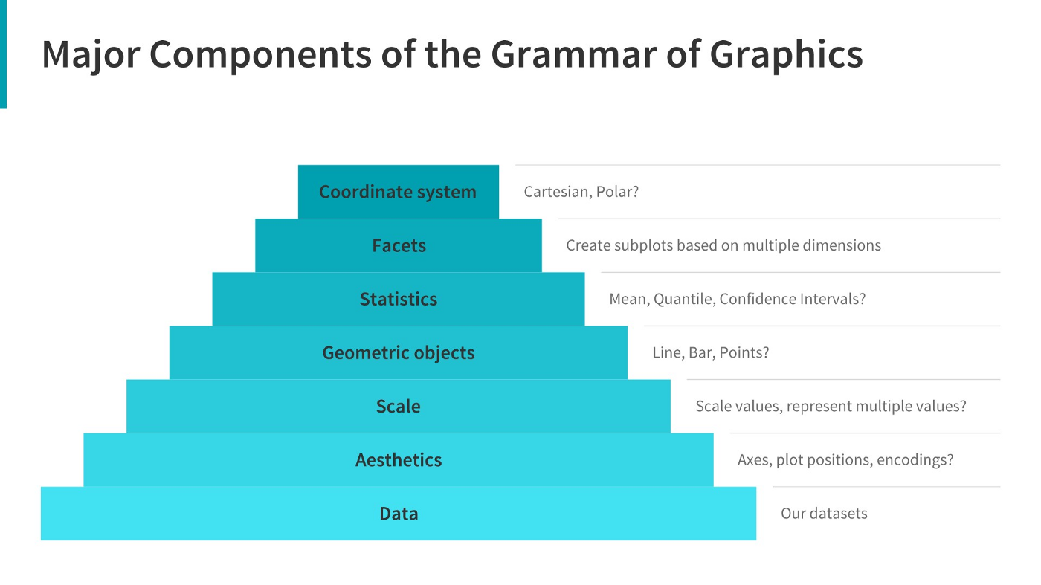

Q1/5: The CEO of the retail store is interested to view the time series of the revenue data for the entire year. The CEO is interested in viewing the seasonal trends and wants to dig deeper into why these trends occur. This analysis will be helpful for the CEO to forecast for the next year. Which visual would most likely help the CEO analyse the data?

Bar chart

* Line chart

Pie chart

Scatter plot

Q2/5: The CMO is interested in viewing the top 10 countries which are generating the highest revenue. Additionally, as a subcomponent, they would also like to see which products are contributing to the total revenue being generated by each country. Which visual would enable the CMO to view the revenue for each country and the breakdown by products on a single chart?

Bar chart

Pie chart

Boxplot

* Stacked bar chart

Q3/5: The CEO of the online retail store wants to see how much average revenue is generated by each country. They are interested in viewing the following metrics on the visual: Minimum value First quartile value Median value Third quartile value Maximum value Which chart would you create to show the above metrics for the average revenue generated by each country?

Scatter plot

Histogram

Waterfall chart

* Boxplot

Q4/5: The CMO of the online retail store wants to view the information on the top 10 customers by revenue. They are interested in a visual that shows the greatest revenue-generating customer at the start and gradually declines to the lower revenue-generating customers. The CMO wants to target the higher revenue-generating customers and ensure that they remain satisfied with their products. Which visual would help the CMO understand the data on revenue generated by the top 10 customers?

Pie chart

Stacked bar chart

* Column chart

Area chart

Q5/5: The CEO is looking to gain insights on the demand for their products. They want to look at all countries and see which regions have the greatest demand for their products. Once the CEO gets an idea of the regions that have high demand, they will initiate an expansion strategy which will allow the company to target these areas and generate more business from these regions. He wants to view the entire data on a single view without the need to scroll or hover over the data points to identify the demand. Which chart would be most useful to provide the CEO information on the demand in each region?

Area chart

Scatter plot

* Map chart

Pie chart